Photographing Your Art  Types of Art  Two Dimensional  Three Dimensional  Textures  Recognizing Light  Quality  Direction  Intensity  Color  Equipment Needed  Cameras  Interchangeable Lens  Smartphone  Lens choices  Lighting  Natural  Artificial  Placement and Quality  Reflector  Color Temperature  Post Processing  Cropping  Geometric Straightening  Saving pixels | More Tips  1. The eye catchers:  Bright  Focused  High Contrast  Warm Colors  2. Depth of field is how deep the focus is. If lens adjustable, use f/8 for flat work and f/11 or f/16 for 3D work.  3. Use a tripod, cable release or self-timer. Set the height of the camera to the middle of the work.  4. Color Rendering Index  High CRI lights - look for numbers above 90 to show color accurately.  5. Camera settings – If possible use a low ISO number and shutter speed above 1/125 second.  6. A gray card will help with color temperature and exposure.  7. Override camera exposure for bright and dark subjects. Look for +/- symbols.  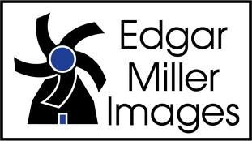
edgarmillerimages.com • 817-975-2886 • edgar@edgarmillerimages.com
328 Hemphill Street Fort Worth, Texas 76104

Convenient QR Code Links

Edgar Miller Images website Instagram

18% Gray Card

Smartphone Tripod Adapter

LED Light Kit
edgarmillerimages.com • 817-975-2886 • edgar@edgarmillerimages.com
328 Hemphill Street Fort Worth, Texas 76104

